HOW TO USE BLOG CONTENT: Always include your library’s web page with information on how to access ChiltonLibrary or the access page itself. Shorten links with bit.ly, if needed.

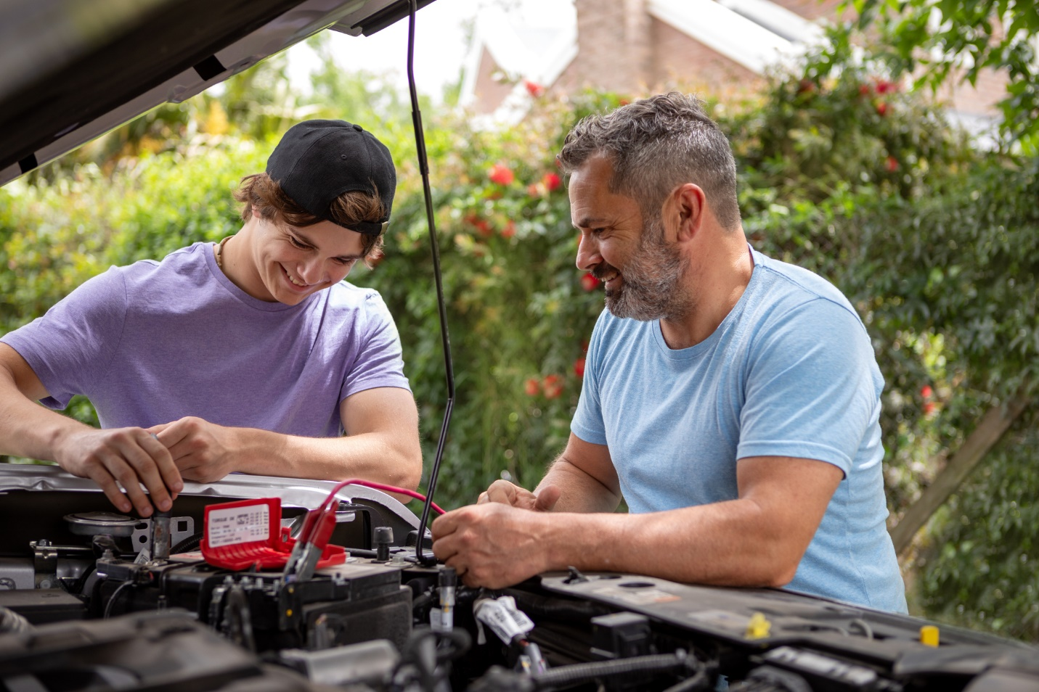

[Headline]Boost Spring and Summer Car Care with ChiltonLibrary

[Headline Alternative] ChiltonLibrary: Essential Resources for Car Enthusiasts

Spring and summer’s longer days and warmer weather lend themselves to tending to our cars. Car owners can refer to ChiltonLibrary to help keep their vehicles operating properly.

Are the air conditioner and ventilation system working properly to temper those hot summer days? Are the brakes making noise? Is there an unusual smell? ChiltonLibrary includes original equipment manufacturer (OEM) diagnostics and repair procedures for each component, including heaters, ventilation, and brakes. Is it time to check the spark plugs? ChiltonLibrary illustrations show how to tell whether to replace the spark plugs, as well as the steps to remove and install them.
Chilton has been trusted by automotive enthusiasts for more than 100 years. Today’s ChiltonLibrary provides access to repair, maintenance, and service information for popular cars, trucks, vans, and SUVs going back several decades. No other source contains more years, makes, and models.

Along with diagnostics and amply illustrated inspection and repair procedures, ChiltonLibrary provides:

- Wiring diagrams and component locations
- Recalls and service bulletins
- Real-time vehicle identification number (VIN) decoding through the
National Highway Traffic Safety Administration (NHTSA) for original equipment and unrepaired safety recalls
- Labor times to help users estimate repair costs
- Body and collision data
- Automotive Service Excellence mechanic certification test prep quizzes
- Accessibility features such as text display options, language translation, and having text read aloud

With its intuitive interface and search tools, ChiltonLibrary is easy to use. Need to save or print something? It’s easy with ChiltonLibrary.

Best of all, ChiltonLibrary is free through [INSERT YOUR LIBRARY]. And, since the need for car care doesn’t always coincide with library hours, ChiltonLibrary is also available online 24/7. Users have access at a time and place that’s convenient for them, using a laptop, desktop, tablet, or phone.

Access ChiltonLibrary from any device, anytime, anywhere at [INSERT YOUR LIBRARY’S ACCESS URL].

